**Infographic of TDD, BDD, and FDD methodologies**

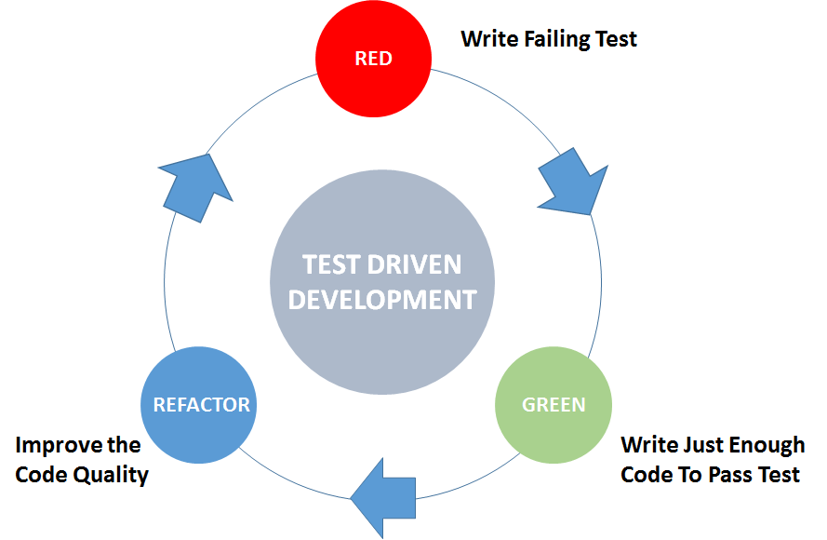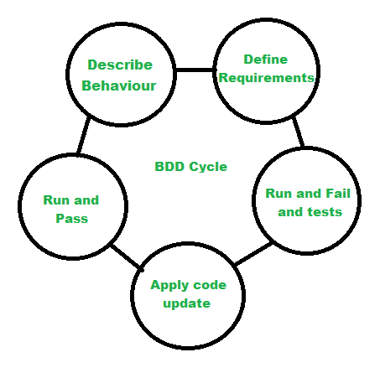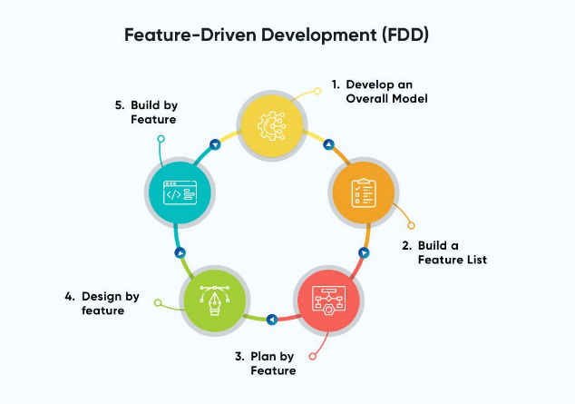

**Test-Driven Development (TDD):**

* **Approach**: Developers write tests before writing the actual code. Tests focus on individual units of code (units, functions, or methods).
* **Benefits**:
  + Early Bug Detection: Bugs are caught early in the development process.
  + Improved Code Quality: Leads to cleaner, more maintainable code.
  + Confidence in Refactoring: Developers can refactor code with confidence, knowing that existing functionality won't be broken.
* **Suitability**: Best suited for projects where requirements are well-defined and the focus is on code correctness and reliability.

**Behaviour-Driven Development (BDD):**

* **Approach**: Focuses on behaviour or interactions of the system from an end-user perspective. Tests are written in a human-readable format using Given-When-Then syntax.
* **Benefits**:
  + Improved Communication: Encourages collaboration between developers, testers, and stakeholders by using a common language.
  + Increased Visibility: Provides a clear understanding of system behaviour and requirements.
  + Customer Satisfaction: Aligns development with customer expectations by focusing on user-centric features.
* **Suitability**: Ideal for projects with changing requirements, complex business logic, or where collaboration between technical and non-technical stakeholders is crucial.

**Feature-Driven Development (FDD):**

* **Approach**: Breaks down development into small, manageable features. Focuses on domain modelling, feature lists, and iterative development.
* **Benefits**:
  + Incremental Delivery: Allows for continuous delivery of features, providing tangible progress to stakeholders.
  + Scalability: Scales well for large projects by breaking them down into smaller, more manageable pieces.
  + Emphasis on Design: Places importance on domain modelling and design, leading to a well-structured codebase.
* **Suitability**: Suitable for large-scale projects with well-defined requirements, where the focus is on feature delivery and iterative development.